Authors: Mahesh Srinivasan, Stephen Conte, Hugh Rabagliati

Words often have multiple distinct but related senses, a phenomenon called polysemy. For instance, in English, words like *chicken* and *lamb* label animals and their meats, and words like *glass* and *tin* label materials and artifacts derived from those materials. We present two projects that explore whether the ways in which senses are related by words–and thus, the structure of polysemy–might be constrained by chlidren’s cognitive biases.

Study 1 used a survey of 15 languages to test whether there are regularities in polysemy across languages, and thus explores whether polysemy reflects conceptual structure, or instead arbitrary language-specific conventions. Consistent with the idea that polysemy is constrained by conceptual structure, nearly all of the 26 patterns of polysemy we surveyed (e.g., animal for meat, material for artifact) were present across languages. However, consistent with the idea that polysemy reflects conventions, patterns were instantiated in senses across languages differently (e.g., the word for glass material labels different glass-artifacts across languages). We argue that these results are best explained by a model in which senses are conventions, but children’s cognitive biases make some senses easier to learn than others, such that the same sense patterns evolve across languages: Children’s cognitive biases shape polysemy, and in turn polysemy makes it easier for children to build a lexicon.

The plausibility of this proposal rests on the idea that young children find polysemy intuitive, and can conceptualize word senses as both related and distinct: chicken animals and meat are related, but different kinds of things. Previous work indicates that children relate the different senses of polysemous words (Srinivasan & Snedeker, 2011, 2014) and even pick up on larger patterns (Srinivasan & Barner, 2013). But we do not know if children also treat word senses as distinct: Do children think that *chicken* labels two distinct kinds of things, or instead a single broad category including both animals and meat?

In Study 2, 49 adults and 49 4-year-olds completed an inductive reasoning task, modeled on Gelman & Markman (1986). Participants chose which of two facts generalized to a critical item (e.g., a chicken animal) on each trial (Figure 1). One fact concerned a visually similar but taxonomically-distinct item (e.g., a *duck*). We varied whether the second fact was about an item from the same kind (chicken animal, labeled as *chicken*) or an item related through polysemy (chicken meat, labeled as *chicken*). Adults only generalized based on the shared label when the item was of the same kind. If children represent polysemous senses as distinct, then they should have similar intuitions. Indeed, 4-year-olds’ inductive generalizations varied in a similar manner to the adults’. Thus, children understand that property inductions depend on kind-status, and not labels alone: despite having the same label, chicken animals and meat are different things, with different properties.

Together, these studies suggest that polysemy may be constrained in part by how young children conceptualize the world. We discuss our results as they relate to theories of cognitive development and lexical semantics.

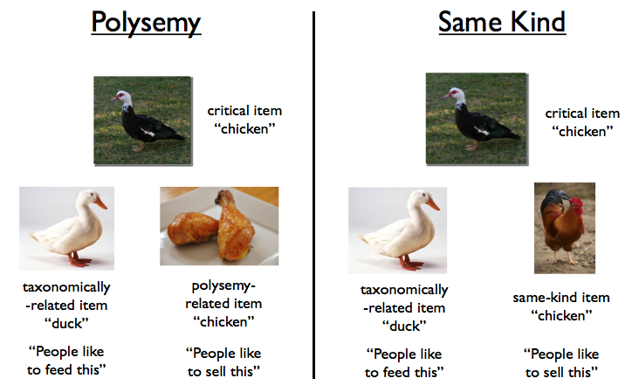

*Figure 1*. Examples of trials from the polysemy and same-kind conditions of Study 2. Subjects were asked to decide which of two facts generalized to the critical item.